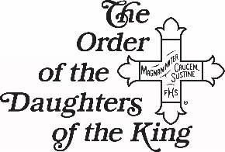

“Be Still and Know That I Am God”
An Awesome God Breathes Life into Our Universe

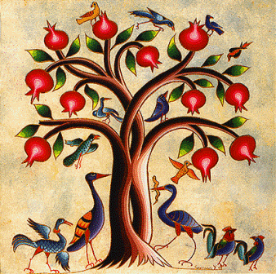

You are cordially invited to the DOK Spring Assembly, March 1-2, 2019
Hosted by the Cecilia Chapter at St. Peter’s Episcopal Church,
2310 Airline Dr. Brenham, TX 77833.
Please visit www.dokdot.org for more information.
Keynote speaker: Heather Bennett, PhD. Biology
Early Bird Rates Available
Vendors Welcome

