Participating Products
Choose a category below to find products with Box Tops on them, or download a complete list of participating products.
- NEW PRODUCTS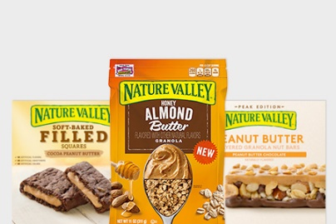
  - Nature Valley™ Granola
  - Nature Valley™ Layered Granola Nut Bars
  - Nature Valley™ Soft-Baked Filled Squares
- BAKING & BAKEWARE 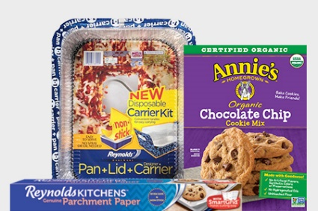
  - Annie’s® Baking Mixes
  - Fiber One™ Mixes
  - Reynolds® Bakeware Pans
  - Reynolds® Oven Bags
  - Reynolds® Parchment Paper
  - Reynolds® Slow Cooker Liners
  - Reynolds® StayBrite® Baking Cups
- CEREAL 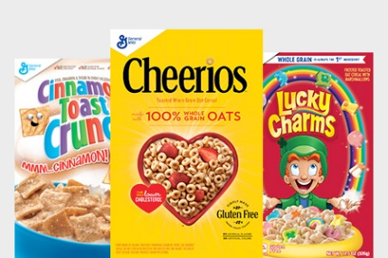
  - Annie’s®
  - Apple Cinnamon Toast Crunch™Cereal
  - Basic 4™ Cereal
  - Batman™ Chocolate Strawberry
  - Blueberry Chex™Cereal
  - Blueberry Toast Crunch™Cereal
  - Cascadian Farm™ Cereal
  - Cascadian Farm™ Farm Stand Harvest Cherry, Almond and Quinoa Granola
  - Cascadian Farm™ Farm Stand Harvest Honey, Almond and Chia Granola
  - Cascadian Farm™ Farm Stand Harvest Vanilla, Coconut and Pumpkin Seed Granola
  - Cheerios™ Cereal
  - Chex™ Cereal
  - Cinnamon Toast Crunch™ Cereal
  - Cinnamon Toast Crunch™ Blasted Shreds™
  - Cocoa Puffs™ Cereal
  - Cookie Crisp™ Cereal
  - French Toast Crunch™
  - Golden Grahams™ Cereal
  - Kix™ Cereal
  - Lucky Charms™ Cereal
  - Lucky Charms™ Frosted Flakes
  - Nature Valley™ Baked Oat Bites
  - Nature Valley™ Chocolate Oat Clusters
  - Nature Valley™ Granola
  - Nature Valley™ Honey Oat Clusters
  - Nature Valley™ Protein Crunchy Granola
  - Oatmeal Crisp™ Cereal
  - Peanut Butter Chocolate Blasted Shreds™
  - Raisin Nut Bran Cereal
  - Reese's Puffs® Cereal
  - Strawberry Toast Crunch™ Cereal
  - Total™ Cereal
  - Trix™ Cereal
  - Wheaties™ Cereal
- FOOD STORAGE 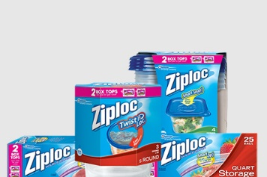
  - Ziploc® Freezer Bags
  - Ziploc® Storage Bags
  - Ziploc® Smart Snap Containers
  - Ziploc® Twist 'n Loc® Containers
- FROZEN 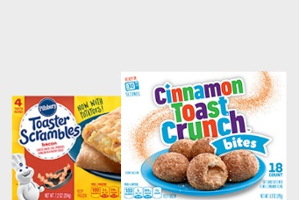
  - Annie's® Frozen Snacks
  - Cinnamon Toast Crunch™ Bites
  - Grands!™ Biscuit Sandwiches
  - Green Giant™ Vegetables
  - Green Giant™ Seasoned Steamers™
  - Green Giant™ Just for One™
  - Green Giant™ Family Size Frozen Vegetables
  - Green Giant™ Valley Fresh Steamers
  - Pillsbury™ Toaster Strudel™
  - Pillsbury™ Toaster Scrambles
  - Totino's™ Party Pizza®
  - Totino's™ Pizza Rolls® Snacks
- HOUSEHOLD CLEANING 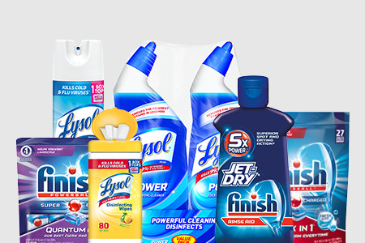
  - Finish® Dishwashing Detergent
  - Lysol® Bathroom Cleaners
  - Lysol® Disinfecting Spray
  - Lysol® Disinfecting Wipes
- MEALS & SIDES 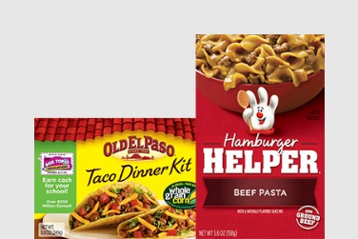
  - Annie's® Mac & Cheese
  - Annie's® Microwaveable Mac & Cheese Cups
  - Annie’s® Soups
  - Betty Crocker™ Specialty Potatoes and Potato Buds
  - Betty Crocker™ Suddenly Salad™ Mixes
  - Green Giant™ Canned Vegetables
  - Hamburger Helper™
  - Old El Paso™ Dinner Kits
  - Old El Paso™ Rice & Beans
  - Old El Paso™ Shells & Seasoning Mixes
- PAPER PRODUCTS 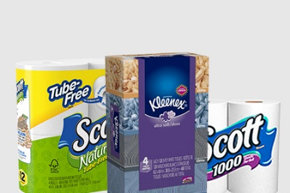
  - Kleenex® Tissue Bundles
  - SCOTT® Bath Tissue
  - SCOTT® Paper Towels
- PRODUCE 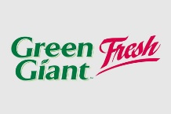
  - Green Giant™ Fresh Vegetables
  - Green Giant™ Fresh Herbs
- REFRIGERATED & DAIRY 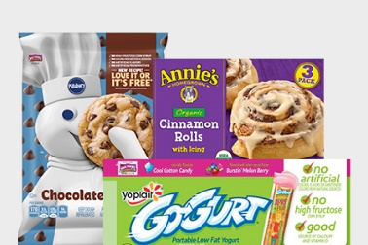
  - Annie’s® Refrigerated Dough
  - Annie’s® Yogurt Tubes
  - Pillsbury™ Refrigerated Cookies
  - Yoplait® Go-Gurt® Yogurt
  - Yoplait® Kids Yogurt
  - Yoplait® Light Fridge Pack (8-count and 12-count)
  - Yoplait® Original Fridge Pack (8-count and 12-count)
  - Yoplait® Trix® Multipack Yogurt
  - Pillsbury™ Melts
- SCHOOL & OFFICE SUPPLIES 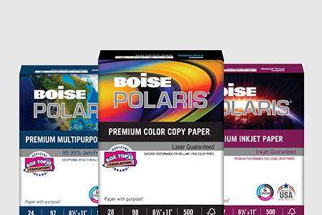
  - Boise® FIREWORX®
Premium Colored Paper
  - Boise® POLARIS®
Premium Color Copy Paper
  - Boise® POLARIS®
Premium Inkjet Paper
  - Boise® POLARIS®
Premium Laser Paper
  - Boise® POLARIS®
Premium Multipurpose Paper
- SNACKS 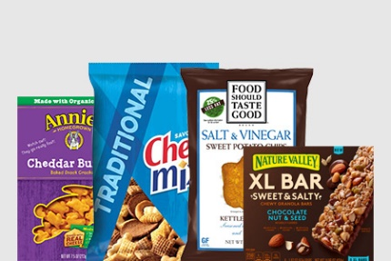
  - Annie's® Cookies
  - Annie's® Crackers
  - Annie's® Fruit Snacks
  - Annie's® Granola Bars
  - Annie's® Organic Popcorn
  - Annie's® Organic Puffs
  - Annie's® Snack Mix
  - Betty Crocker™ Fruit Flavored Snacks
  - Bugles™
  - Cascadian Farm™ Granola Bars
  - Cereal Treat Bars
  - Chex Mix™
  - Fiber One™ Bars and Brownies
  - Fiber One™ Cookies
  - Fiber One™ Fruit Snacks
  - Fiber One™ Streusel
  - Food Should Taste Good™ Chips
  - Gardetto's™
  - LÄRABAR™
  - LÄRABAR™RENOLA Grain Free Granola
  - Mott's® Fruit Flavored Snacks
  - Nature Valley™ Bars
  - Nature Valley™ Backpacker Chewy Oatmeal Bites
  - Nature Valley™ Baked Oat Bites
  - Nature Valley™ Biscuit Sandwiches
  - Nature Valley™ Clusters
  - Nature Valley™ Granola Cups
  - Nature Valley™ Layered Granola Nut Bars
  - Nature Valley™ Protein Soft Baked Granola Bites
  - Nature Valley™ Soft-Baked Filled Squares
  - Nature Valley™ XL Sweet & Salty Bars
- TABLEWARE 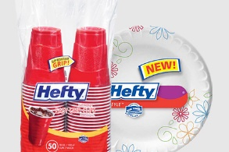
  - Hefty® Easy Grip® Cups
  - Hefty® Deluxe™ Plates and Platters
  - Hefty® Everyday™ Soak Proof Bowls
  - Hefty® Everyday™ Soak Proof Plates
  - Hefty® Style™ Prints Cups
  - Hefty® Style Plates
  - Hefty® Ultimate™ Easy Grip® Cups
  - Kleenex® Dinner Napkins
- WASTE BAGS 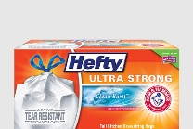
  - Hefty® BlackOut® Tall Kitchen Drawstring Bags
  - Hefty® Cinch Sak® Large Trash Bags and Lawn & Leaf Bags
  - Hefty® Easy Flaps® Tall Kitchen Bags and Large Trash Bags
  - Hefty® OdorBlock® Tall Kitchen Drawstring Bags
  - Hefty® Renew® Tall Kitchen Bags and Trash Bags
  - Hefty® SteelSak® Trash Bags
  - Hefty® Twist Tie Tall Kitchen Bags and Trash and Lawn & Leaf Bags
  - Hefty® Ultimate™ Tall Kitchen Drawstring Bags
  - Hefty® Ultra Flex® Trash Bags

