Keynote Speaker Professor Patricia H. Reiff

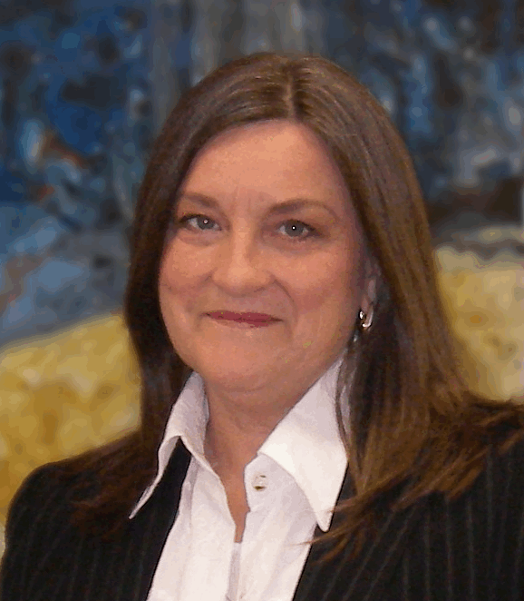
Professor Patricia H. Reiff is a Professor in the Department of Physics and Astronomy and is the founding Director of the Rice Space Institute at Rice University. Her research focuses on space plasma physics, mostly in the area of magnetospheric physics: otherwise known as "space weather". She is instrumental in bringing real-time space weather forecasts and "Space Weather" information to the public. Over ten million people have interacted with her exhibits and planetarium shows at the Houston Museum of Natural Science as well as other museums, and another five million with her web sites. Over 300,000 of her educational CD and DVD-Roms and planetarium videos have been distributed through her spinoff company spaceupdate.com. She has served on numerous advisory committees to many organizations including NASA. Professor Reiff has guided many solar eclipse trips all over the world and has been a leader in public education activities having taught thousands online and in person how to safely view the solar eclipse. In 2017 she gave away more than 35,000 eclipse glasses to teachers and the public. A recent collaborative venture is the creation and marketing of "Discovery Domes", portable digital theaters to teach earth and space science through her distribution company ePlanetarium resulting in over 350 installations in 38 countries and 35 states. In 2013 she won the "SPARC" Award (Space Physics and Astronomy Richard Carrington Award) for service in public education.
She recently won two lifetime achievement awards (in both cases, the very first presentation of the award). The "Marjorie Corcoran Award" from Rice University honors the memory of Physics professor Marj Corcoran whose mentoring of teachers and underserved students is the basis of the award. The second major award is the "STEM Influencer Award" from the Women's Energy Network in honor of educating women in STEM careers.
Her Youtube channel http://www.youtube.com/eplanetarium/ allows you to view all her full-dome planetarium shows for free and her educational videos about space science are located on the web at http://mms.rice.edu/ , a Rice Website.
These are but a few of the highlights of her Curriculum Vitae which is longer than some books. Her awards and papers are too numerous to mention.
Pertinent to her keynote presentation she wrote a chapter, "Three Heavens - Our Home", for a book entitled Professors Who Believe. She is an actively practicing and believing Methodist.
Somehow amidst all of this scientific activity she made time to raise 3 children (2 were twins!) with her husband, an entire family of Rice graduates. She enjoys weekends at her ranch in Field Store just a few miles from Camp Allen.
Professor Reiff has spoken before incredibly diverse groups from Scout troops to international astrophysics symposiums. She comes to us, the Daughters of the King®: exploring the awesome, dazzling expanse of God’s infinitely large and infinitely small inanimate creation. Please, welcome “Professor Pat” to our Assembly.

